**AngularJS**

**Name :** Murali S

**RollNo :** CB.EN.U4CSE19635

**Date :** 27.10.22

**Idea:**

Created an register form to get details from user

Created an data.txt to retrive data from file and show in html page

**Pics:**

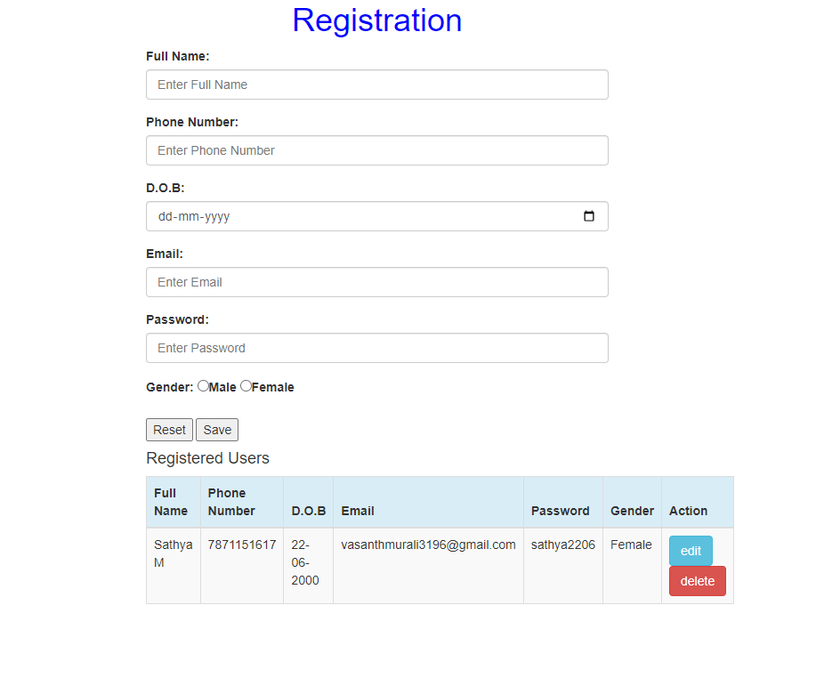

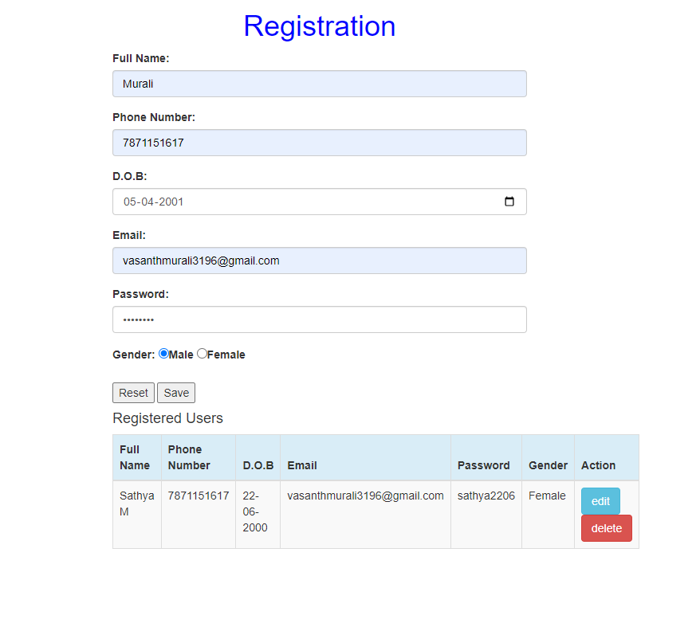

After pressing edit value in the text box will change to value in the registered users

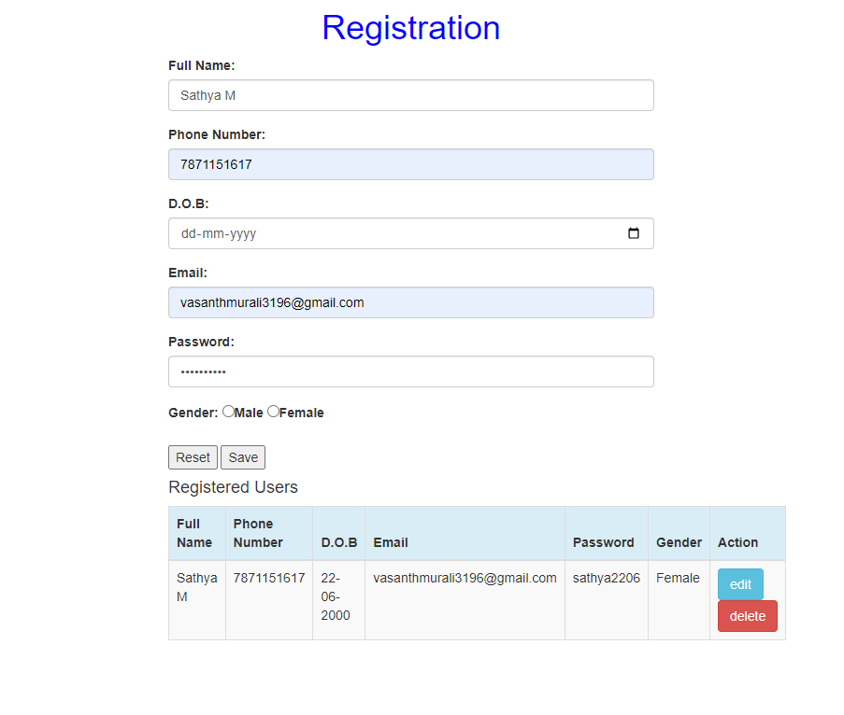

After Pressing delete the value in the registered user will be erased

